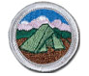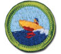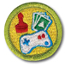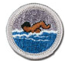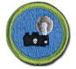

Introduction to Merit Badges – www.scouting.org
You can learn about sports, crafts, science, trades, business, and future careers as you earn merit badges. There are more than 130 merit badges. Any Boy Scout may earn a merit badge at any time. You don't need to have had rank advancement to be eligible.
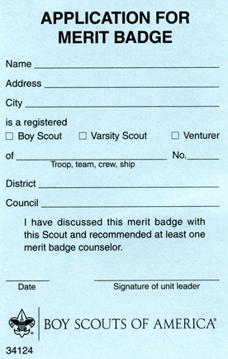
- Pick a Subject. Talk to your unit leader (Scoutmaster) about your interest in earning a merit badge. Read the requirements of the merit badges you think might interest you. Choose one to earn. Your unit leader (Advancement Coordinator) will give you a signed merit badge application (the "blue card") and the name and contact information of a merit badge counselor. These individuals have special knowledge in their merit badge subjects and are interested in helping you.
- Use the Scout Buddy System. You must have another person with you at each meeting with the merit badge counselor. This person can be another Scout, your parents or guardian, a brother or sister or other relative, or a friend.
- Call the Merit Badge Counselor. Get in touch with the merit badge counselor and tell them that you want to earn the merit badge. The counselor may ask to meet you to explain what is expected and to start helping you complete the requirements. You should also discuss work that you have already started or possibly completed.
- Unless otherwise specified, work for a requirement can be started at any time. Ask your counselor to help you learn the things you need to know or do. You should obtain and read the merit badge pamphlet on the subject.
- Show Your Stuff. When you are ready, call the counselor again to make an appointment. When you go take along the things you have made to meet the requirements. If they are too big to move, take pictures or have an adult tell in writing what you have done. The counselor will test you on each requirement to make sure you know your stuff and have done or can do the things required.
- Get the Badge. When the counselor is satisfied that you have met each requirement, they will sign your application (the "blue card"). Give the signed application to your unit leader so that your merit badge emblem can be secured for you.
- Requirements. You are expected to meet the requirements as they are stated—no more and no less. You must do exactly what is stated in the requirements. If it says "show or demonstrate," that is what you must do. Just telling about it isn't enough. The same thing holds true for such words as "make," "list," "in the field," and "collect," "identify," and "label."

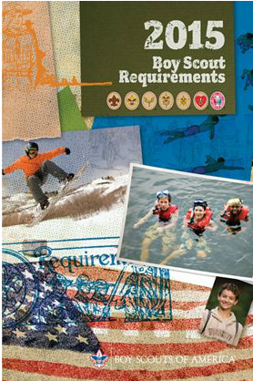
The current Boy Scout Requirements book is available from your local Scouting merchandise distributor. It may also be ordered online at www.scoutstuff.org. Merit badge requirements are revised as needed to reflect updated information and technology.

The requirements listed here are the official requirements of the Boy Scouts of America. However, the requirements presented here might not match those in the Boy Scout Handbook and the merit badge pamphlets, because these publications are updated only when the Boy Scout Requirements book is updated.

If you have already started working on a merit badge when a new edition of the pamphlet is introduced, you may continue to use the same merit badge pamphlet and fulfill the requirements therein to earn the badge. You do not need to start all over again with the new pamphlet and revised requirements.

